HTML BASIC TAGS

**Skeletal Tags**

Let's discuss some basic HTML tags known as **"skeletal tags"**.

**<html> Tag: "Root of an HTML Page"**

**Syntax:**

<html>

<!-- Content -->

</html>

Copy

The <html> tag is the root element that wraps all the content on the page. It generally contains two main sections: the header (<head>...</head>) and the body (<body>...</body>).

**<head> Tag: "Header Part of an HTML Page"**

**Syntax:**

<head>

<!-- Header Content -->

</head>

Copy

The <head> tag contains meta information and the title of the document. While the title appears in the browser tab, meta information is often used for SEO purposes.

**<title> Tag: "Title Part of an HTML Page"**

**Syntax:**

<title>

// Title Name

</title>

Copy

The <title> tag defines the title of the document, which is displayed in the browser's title tab.

**<body> Tag: "Body Part of an HTML Page"**

**Syntax:**

<body>

// Body Content

</body>

Copy

The <body> tag encloses the main content of the page, and everything within this tag is displayed in the browser.

The image below shows the skeletal tags and essential tags needed to define the layout of a webpage:

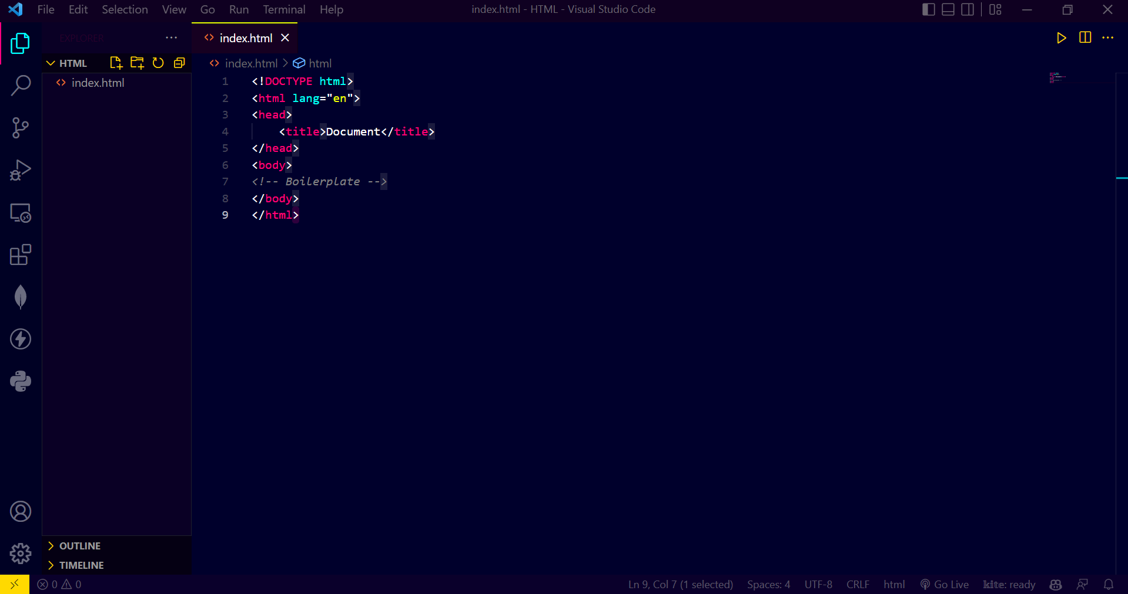

# Heading Tags

In HTML, heading tags ranging from <h1> to <h6> are used to define the structure and layout of text on a web page. These tags help create a hierarchical organization of content, making it easier for both users and search engines to understand the page's content.

The <h1> tag is generally used for the main title and is the largest and most prominent, while <h2> to <h6> tags are used for subheadings, further subheadings and so on... Proper use of heading tags not only improves the readability of a web page but also optimizes it for [search engine ranking in Google](https://www.searchenginejournal.com/heading-tags-for-seo/341817/)

### <h1> Tag: First-Level Heading

The <h1> tag defines the first-level heading and is typically the largest and boldest among all the heading tags. It is often used for the main title of the page.

<h1>

<!-- Heading content -->

</h1>

Copy

### <h2> Tag: Second-Level Heading

The <h2> tag is used for second-level headings and is slightly smaller than the <h1> tag. This is commonly used for section titles.

<h2>

<!-- Heading content -->

</h2>

Copy

### <h3> Tag: Third-Level Heading

The <h3> tag is used for third-level headings. These are smaller than <h2> tags and are often used for sub-sections within an <h2> section.

<h3>

<!-- Heading content -->

</h3>

Copy

### <h4> Tag: Fourth-Level Heading

The <h4> tag defines a fourth-level heading, which is smaller than the <h3> tag. It's often used for sub-sections within an <h3> section.

<h4>

<!-- Heading content -->

</h4>

Copy

### <h5> Tag: Fifth-Level Heading

The <h5> tag is used for fifth-level headings and is smaller than <h4> tags. These are rarely used but can be helpful for deeply nested sections.

<h5>

<!-- Heading content -->

</h5>

Copy

### <h6> Tag: Sixth-Level Heading

The <h6> tag defines the sixth-level heading and is the smallest among all the heading tags. It's rarely used but can serve specific formatting needs.

<h6>

<!-- Heading content -->

</h6>

Copy

### Summary

* **<h1> Tag**: Used for the main title of the page; largest and most prominent heading.
* **<h2> Tag**: Used for major section headings; smaller than <h1> but still quite prominent.
* **<h3> Tag**: Used for sub-sections within an <h2> section; smaller than <h2> but larger than <h4>.
* **<h4> Tag**: Often used for headings within an <h3> section; useful for further breaking down content.
* **<h5> Tag**: Rarely used; suitable for deeply nested sections or less important headings.
* **<h6> Tag**: The smallest heading tag; used for very specific or minor headings, rarely seen in general usage.

Here is how you can create all these headings:

**Paragraph Tag**

To create well-structured text in your HTML document, the <p> tag is essential for defining paragraphs.

**<p> Tag: Defining a Paragraph in HTML**

The <p> tag is used to format text into distinct paragraphs. Each paragraph element is separated by automatic empty line spaces above and below the content, providing a clear visual separation. The tag must be closed with its corresponding </p> tag.

<p>

<!-- Paragraph content -->

</p>

Copy

**Attributes and Styling**

While the <p> tag is straightforward, you can enhance its functionality using various attributes like class or id for CSS styling. You can also include inline styles using the style attribute.

<p class="example" style="color: blue;">

This is a styled paragraph.

</p>

Copy

**Best Practices**

It's advisable to use the <p> tag for textual content and not for layout control. For layout purposes, consider using HTML5 semantic tags like <section>, <article>, or CSS techniques.

Dont worry we will look into semantic tags and other techniques later in this tutorial. Here is how you can create a paragraph in html:

**Horizontal Line Tag**

To add a horizontal line in your HTML document, the <hr> tag comes in handy.

**How to use the <hr> tag?**

The syntax of the hr tag looks something like this.

<hr>

Copy

The <hr> tag is an empty or self-closing tag, meaning it doesn't require a closing tag. It serves as a visual separator, dividing different sections of your document with a horizontal line.

Watch this quick demo video:

**Line Break Tag**

To insert a line break in your HTML document, you can utilize the <br> tag.

<br> tag is used to insert line breaks in text or paragraphs

The syntax for the <br> tag looks like this:

<br>

Copy

The <br> tag is commonly referred to as an empty or self-closing tag, meaning it doesn't require a closing tag. This tag is responsible for breaking text lines or separating paragraphs. When implemented, it automatically moves the text following the tag to the next line.

It's particularly useful in formatting textual content where line breaks are essential for readability or visual layout. For instance, it can be used in addresses, poems, or song lyrics to preserve the original line structure.

**Here is a quick video showing how to use br tag:**

# Anchor Tag

Links are fundamental to navigating the web. In HTML, links are created using the <a> tag, also known as the Anchor tag.

### Key Characteristics of HTML Links

* Specified by the <a> tag.
* Also known as hyperlinks.
* Used to link one document to another.
* Includes a closing tag </a>.

### Syntax of HTML Links

<a href="Your specified path">

content

</a>

Copy

### Essential Attributes of the Anchor Tag

HTML links primarily use two attributes:

* **href attribute:** Defines the URL the link points to.
* **target attribute:** Specifies where to open the linked document.

#### Target Attribute Values

* **_blank:** Opens the linked document in a new window or tab.
* **_top:** Opens document in the full body of the window.
* **_self:** Opens document in the same window or tab (default behavior).
* **_parent:** Opens the linked document in the parent frame.

### Linking to Specific Page Sections

To link to a specific section of a webpage, you can:

* Use the name or id attribute of the target section.
* Use a hyperlink with a hash (#) followed by the target id or name.

#### Example

Let's say you have a long webpage with multiple sections, and you want to create a link at the top that, when clicked, takes the user directly to a specific section further down the page. You can do this using HTML links that target specific sections.

<!DOCTYPE html>

<html>

<head>

<title>My Webpage</title>

</head>

<body>

<!-- Link at the top -->

<a href="#gardening-tips">Go to Gardening Tips</a>

<!-- Some content -->

<p>Here is some other content...</p>

<!-- Gardening Tips Section -->

<h2 id="gardening-tips">Gardening Tips</h2>

<p>This section provides tips on how to garden...</p>

</body>

</html>

Copy

### Link Colors

Links typically appear in different colors based on their state:

* **Active:** Displayed in red and underlined like this sentence
* **Visited:** Appears purple and underlined like this sentence
* **Unvisited:** Shown as blue and underlined like this sentence

You can customize these colors using CSS to better match the style of your website.

# Image Tag

Images play a crucial role in enhancing web pages by providing a visual context that complements textual content. In HTML, the <img> tag is used to embed images into web pages.

### Basic Syntax for Embedding Images

This is how the syntax to embed an image in html looks like:

<img src="image's path" />

Copy

### Key Features of the <img> Tag

* It's a self-closing tag, meaning it doesn't require a corresponding closing tag.
* Commonly used attributes include the "alt" attribute for image descriptions and the "src" attribute for specifying the image location.
* Supports various image formats including PNG, JPEG, JPG, and GIF.

#### Setting Mandatory Attributes

The "src" and "alt" attributes are essential for the proper functioning of the <img> tag.

* **src attribute:** Specifies the path to the image file.
* **alt attribute:** Provides a text description for the image.

<img src="images/profile_picture.jpg" alt="Profile Picture" />

Copy

**Note:** To find the image's location, right-click on the image, go to properties, and check the location field.

#### Setting Image Dimensions

Although dimensions can be set using the "width" and "height" attributes in the <img> tag, modern best practices recommend using CSS for this purpose.

<img src="image.png" alt="Description" width="300" height="100" />

Copy

Setting the width and height attributes for images in HTML can have a positive impact on [Search Engine Optimization (SEO)](https://searchengineland.com/guide/what-is-seo). Specifying these dimensions in the <img> tag allows browsers to allocate the correct amount of space on a web page even before the image is fully loaded. This prevents layout shifts, improving the [Cumulative Layout Shift (CLS) score](https://web.dev/cls/)—a key metric in Google's Core Web Vitals. A better CLS score can lead to a higher page ranking in search engine results.

Note: Styling dimensions and other properties are now more commonly managed through CSS for better flexibility and maintainability.